NFR Training

# Key Implementations

## Security

* Added Content Security Policy header in response.
* Demonstrated Angular’s way of handing CSRF by setting a XSRF-TOKEN cookie which Angular puts in the header as X-XSRF-TOKEN header.
* Angular already sanitizes/escape the HTML strings and render its text value, hence protecting the site from XSS attack.
* Secure, HTTP only and Samesite cookies being used in the website.

## Performance

* Lazy loading of modules for small bundle size and initial load
* Angular universal app enabled (with cookie implementation + CSRF protection)
* Angular PWA enabled
* Handled Cumulative Layout Shift on Home Page – footer was resulting in CLS
* Build files compressed using gzip during build time and served using express server (created for SSR).
* Preloaded google font with display: swap property. The text is shown as soon as possible using the default font and once the google font becomes available, the font gets changed.
* Content was loading twice - once due to SSR and then when Angular kicks in (ngOnInit) – handled using TransferHttpCacheModule module.
* Used webp format for images. Example – fruits image with a size of 500+KB was reduced to less than 100 KB.
* Handled logo with high DPR image support.
* CLS handled using aspect-ratio-box on PLP page.

## SEO

* Server side rendering using Angular Universal.
* Created a dedicated SEO service in angular application.
* Change the title of the page.
* Change the meta description of the page.
* Used canonical URLs for all the pages.
* Serve robots.txt file.
* Use of semantic HTML.
* Use of properly structured headlines.
* Usage of meaningful URLs. For example, not passing IDs in the URLs

## Accessibility

* Skip to main content for navigating directly to the main area of the website.
* Use of alt tags for all images.
* Fixed contrast issues reported by lighthouse.
* Ability for screen readers to read the content.
* Usage of aria tags such as aria-label, aria-describedby, aria-live, etc.

## Further Enhancements

* Sign up and login pages have some duplicate code which can be refactored.
* Use variables in SCSS files for sizes, media queries, etc - done partially for colors.
* Loader icon to be implemented.
* IE 11 currently not supported. Supporting it will increase the bundle size due to more polyfills being included.
* Screen reader reading issues in carousel from ngx-bootstrap.

# Lighthouse Report

## Login Page

### Desktop

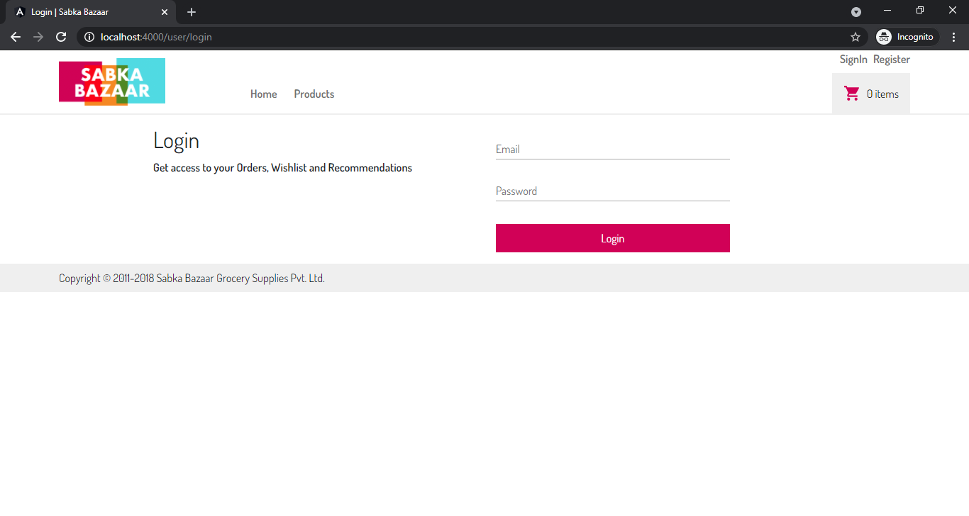

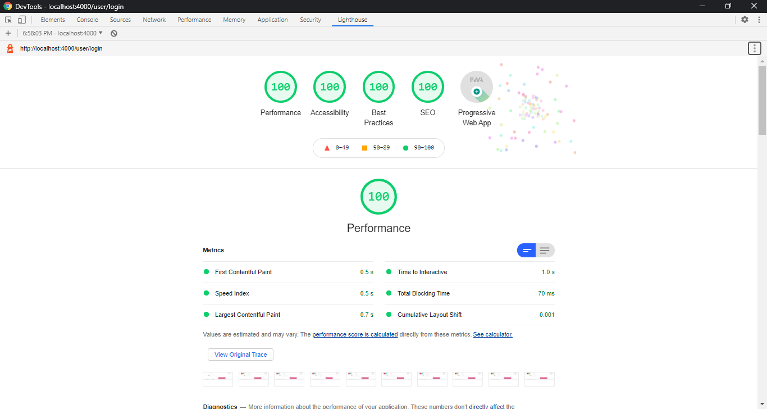

### Mobile

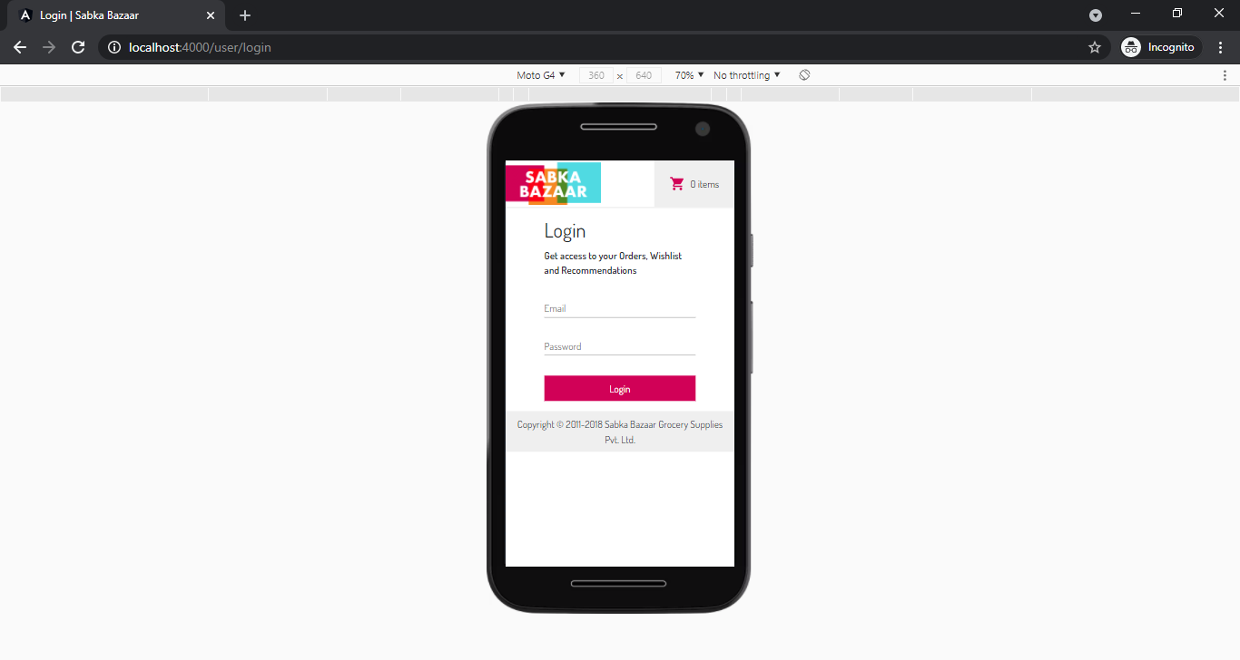

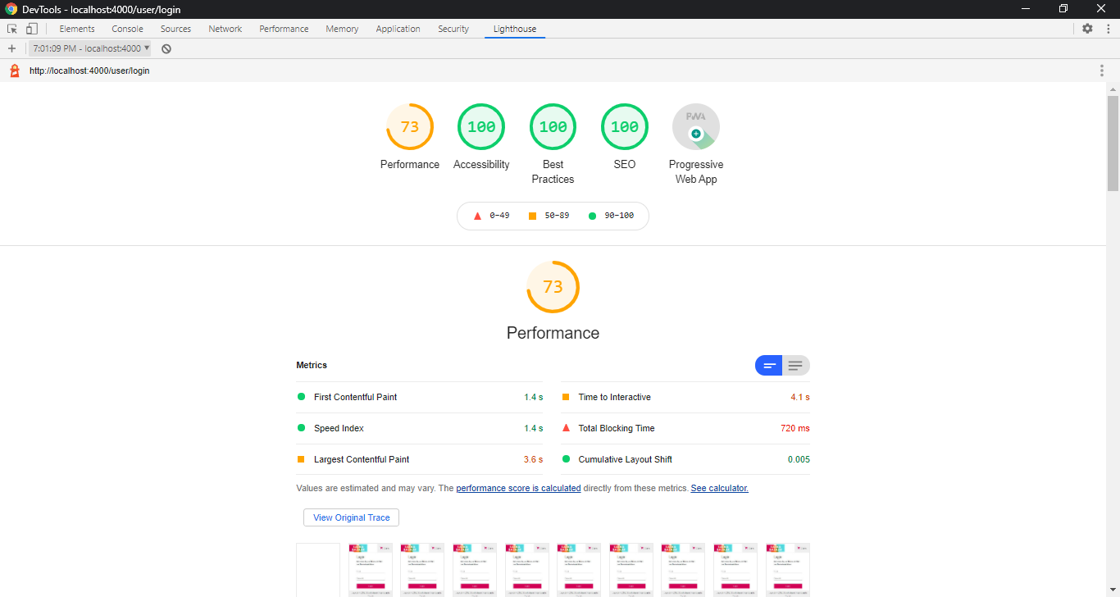

## Signup Page

### Desktop

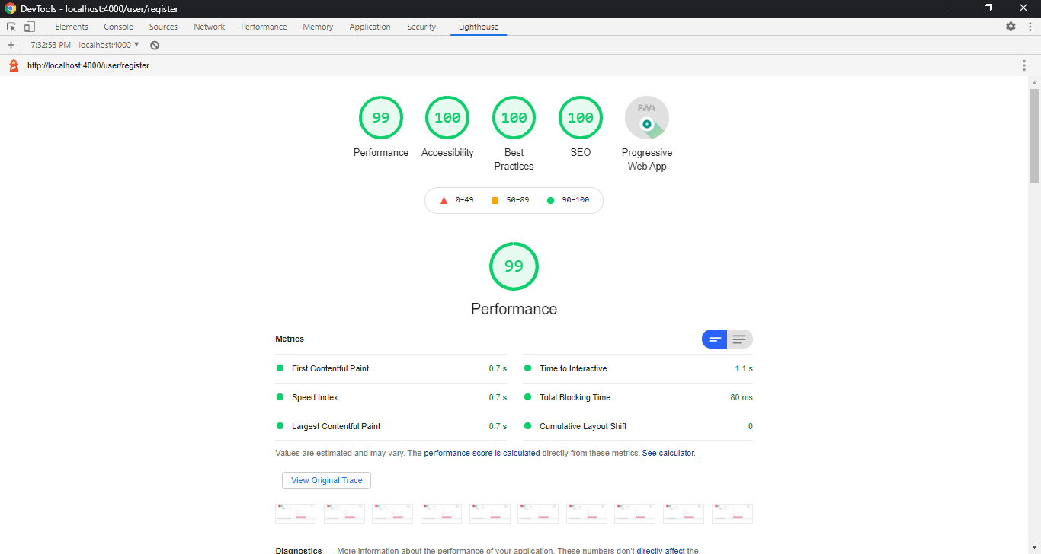

### Mobile

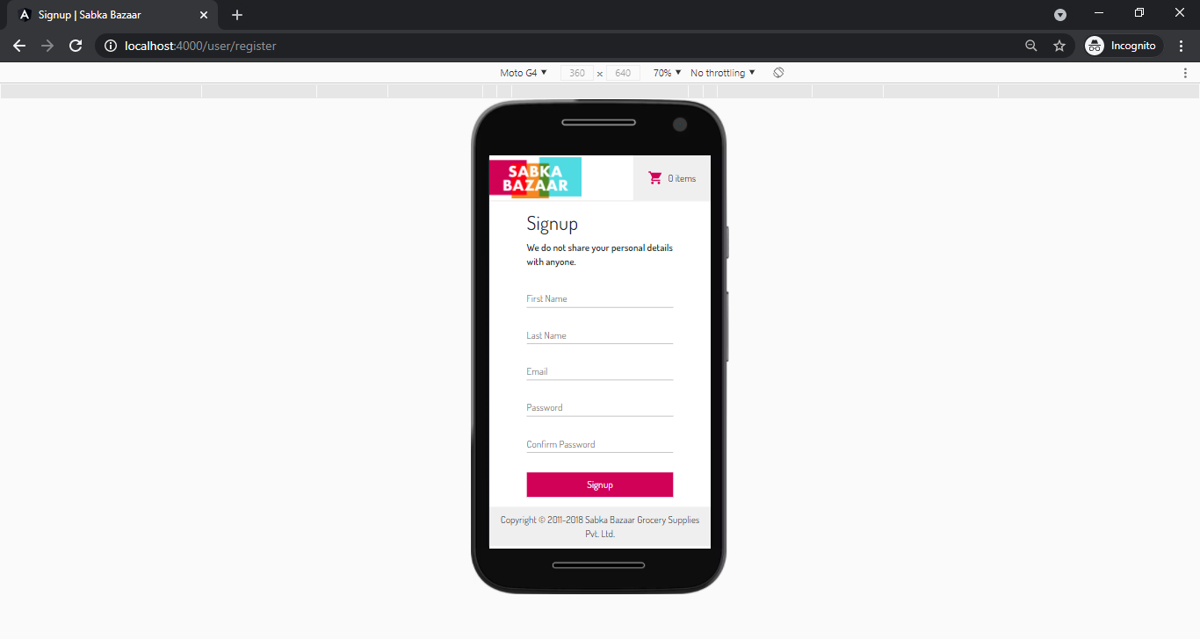

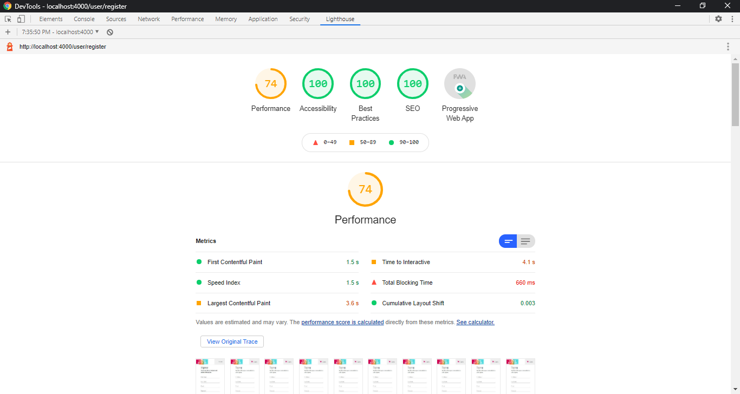

## Home Page

### Desktop

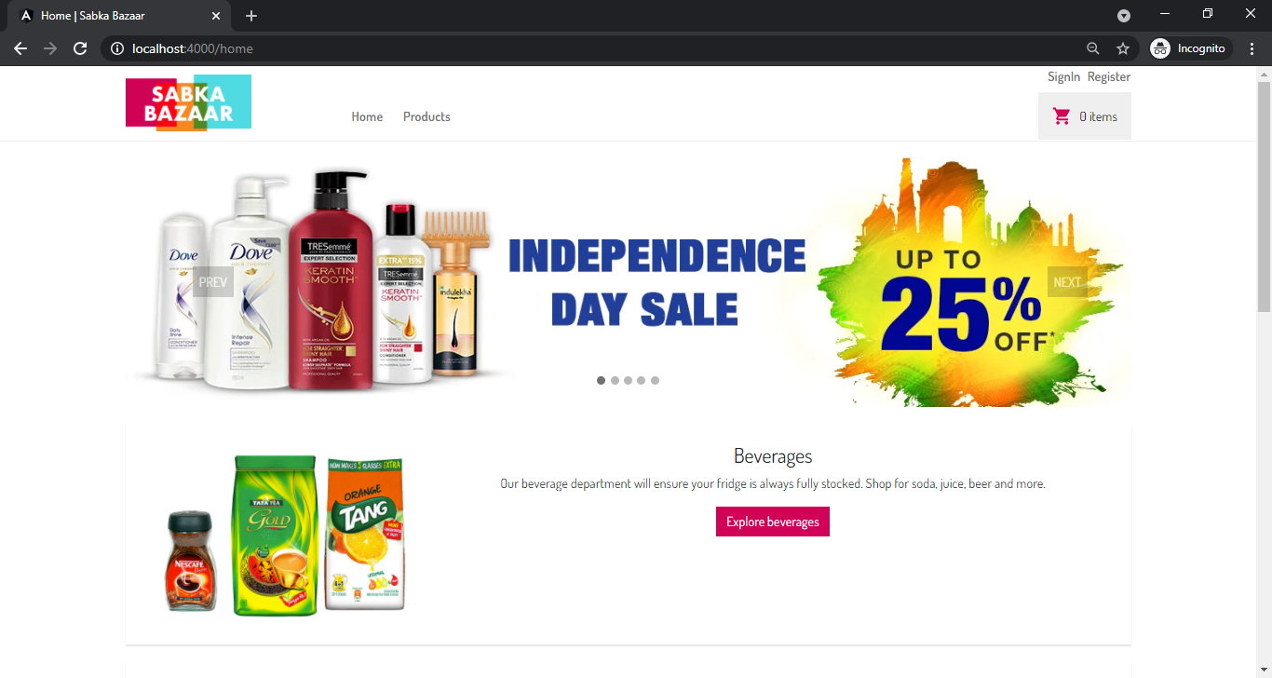

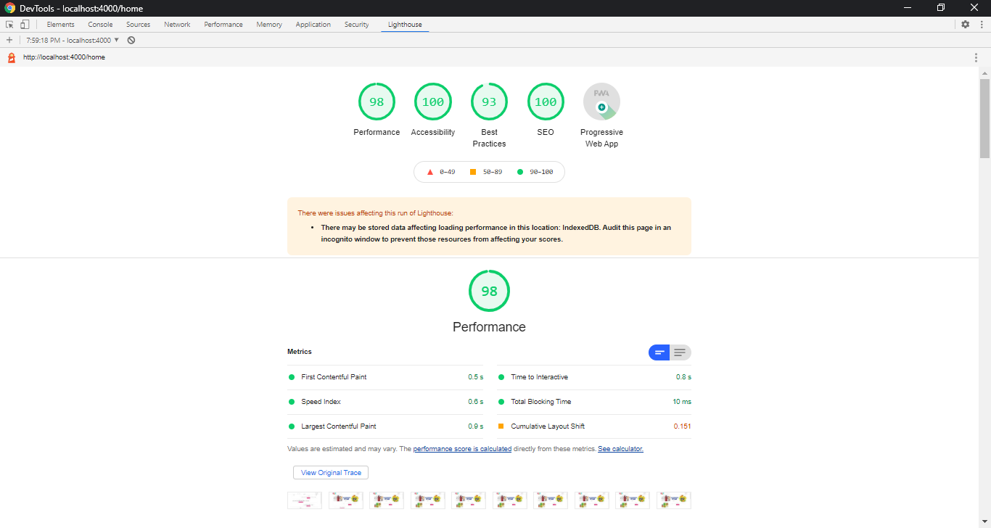

### Mobile

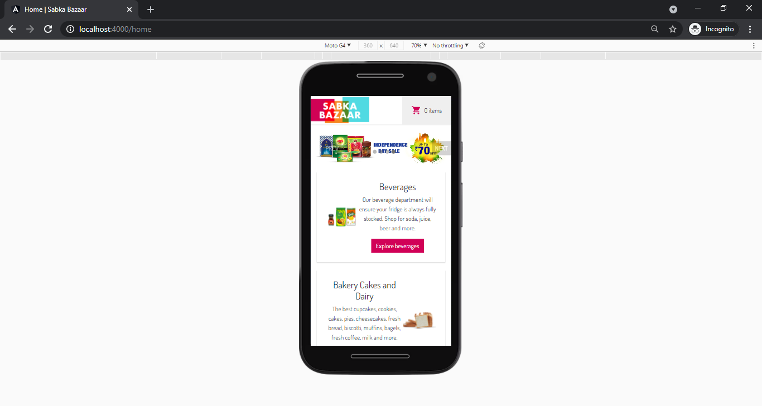

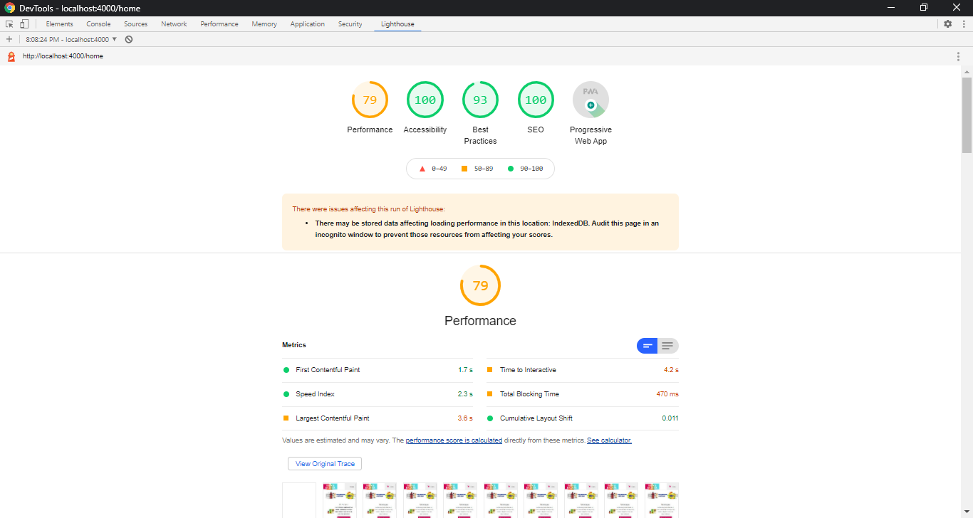

## Products Page

### Desktop

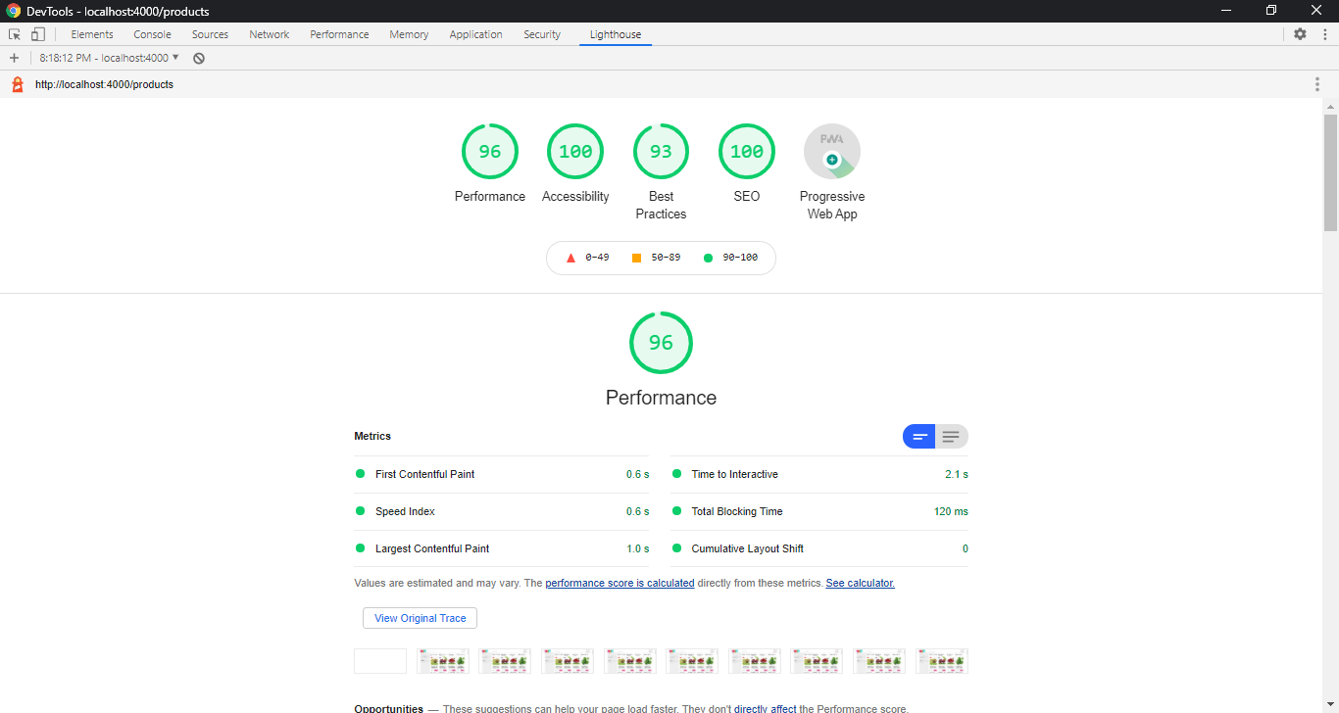

### Mobile

